Low Carbon Communities Initiative
Networking Key Services- NKS

Guide for Using Public Transport in Edinburgh
Why take public transport?
Environmental benefits
- Using public transport reduces emissions which contribute to greenhouse gases and climate change
- For example, “Buses emit 20% less carbon monoxide, 10% as much hydrocarbons, and 75% as much nitrogen oxides per passenger mile than an automobile with a single occupant” (National Express Transit, 2019)
- Using public transport is fuel efficient, with dozens of people taking the same bus instead of individual cars
Personal Benefits
- Using public transport allows you to access all of Edinburgh and to explore this beautiful city without relying on a car or driver
  - There are more than 52 bus routes that will help you explore and commute around Edinburgh and outside areas!
- A recent study from the University of East Anglia has shown using public transport can improve mental health compared to driving individual cars
- Using public transport can save money
  - You can travel long distances with one fare
  - You do not have to pay ever increasing fuel prices
Community Benefits
- Using public transport offers you the chance to connect with your community by contributing to public infrastructure and jobs
- Commuting with others in a shared form of transport also offers you a chance to connect with your community

Important link to use : https://www.nationalexpresstransit.com/blog/9-benefits-of-public-transportation/
https://www.independent.co.uk/life-style/health-and-families/health-news/taking-public-transport-instead-of-driving-to-work-makes-people-happier-study-suggests-9732535.html
https://www.lothianbuses.com/our-services/lothian-city-buses/

How to take public transport?

- Find out where you need to go
  - Use www.google.com/maps
    - Click directions
    - Click the “Transit” option
  - You can also use www.lothianbuses.com
    - Use the “Plan a journey” tool on the lower left hand screen
    - Please note that there are other bus companies in Edinburgh, like First, although Lothian is the “dominant operator.”
Useful link: https://www.introducingedinburgh.com/bus
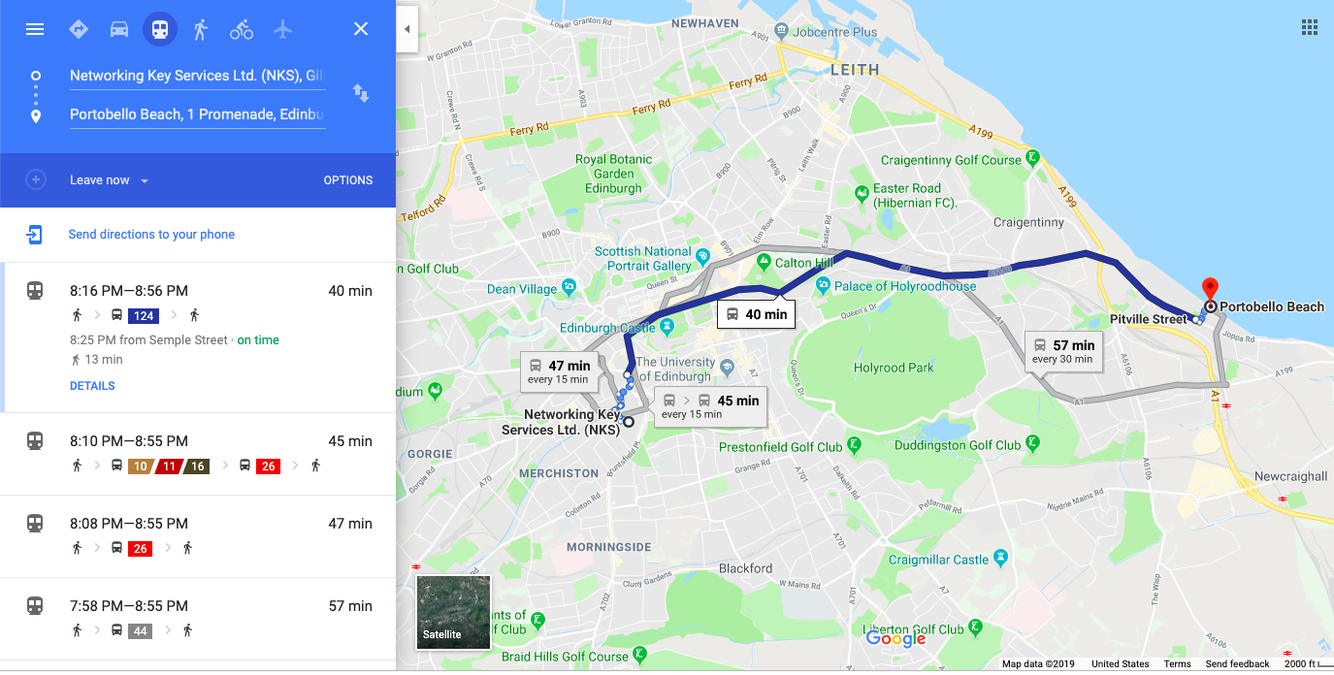

This example shows how to get to Portobello Beach from the NKS office. Click the bus icon on the top left corner. Choose the best options; consider how much walking is involved and how much time it takes, which is shown on the right side.

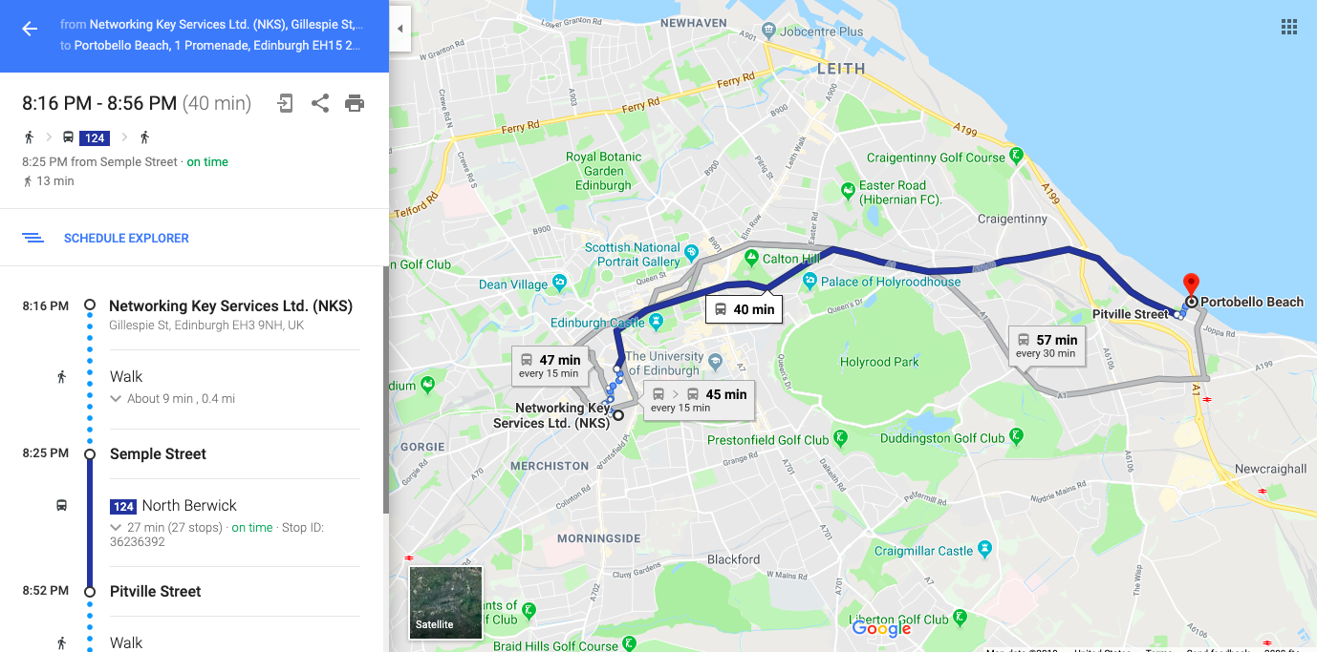

Click on your preferred option and it will show you how to get to Portobello Beach using public transport in Edinburgh. For example, you have to walk from NKS to Semple Street, where you will catch bus 124 going to North Berwick (the bus will clearly indicate this destination). You will then exit on Pitville Street.

- Get tickets
  - This may differ depending on the type of bus you are taking. If it is through Lothian, there are many ways to get tickets.
- There are many ways to get tickets
  - You can pay your fare when you get on the bus
    - Make sure it is exact change and that you state what type of ticket you are purchasing to the driver
    - There are different kinds of tickets:
      - Adult single ticket (one journey) £1.70
      - Night ticket (after midnight) £3.00
      - Day ticket (entire day) £4.00

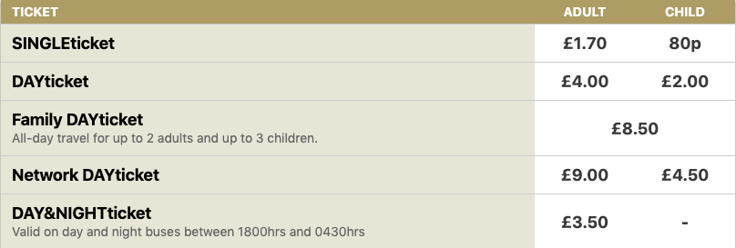(Lothian Buses, 2019)

  - You can purchase a Ridacard
  - This is a good option if you travel by bus often, as you can save a lot of money

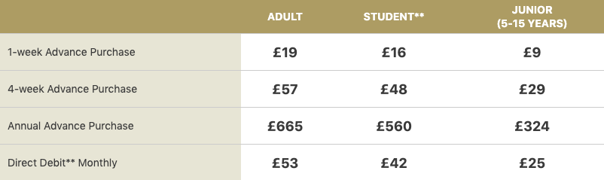
(Lothian Buses, 2019)

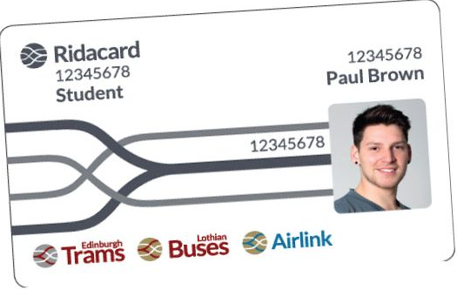

(Edinburgh Trams, 2014)

- You can purchase a Ridacard at any Travel shop in Edinburgh. There is one in Waverly Station in central Edinburgh.
-put map
- You can also purchase tickets through the app “Transport for Edinburgh”
  - Using your credit or debit card, you can purchase any kind of ticket

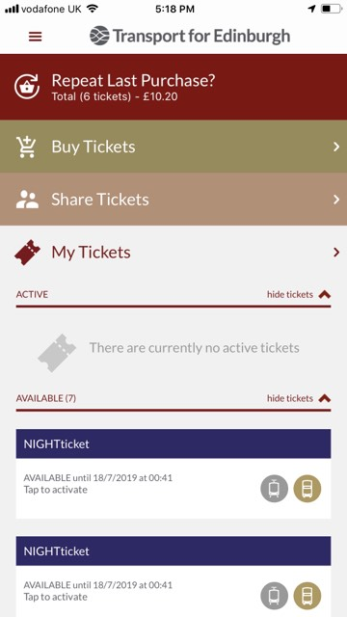
(Sonya Peres, 2019)

Public transport can help you see the beauty and history of Edinburgh which is right in your own backyard.

Here are some beautiful routes you can take:

http://www.scotlandnow.dailyrecord.co.uk/lifestyle/5-edinburgh-bus-journeys-you-7539136

Additionally, Edinburgh Bus Tours are double-decker buses that show you around the city. Although they are not a standard city bus, they can take you to destinations like the Edinburgh Castle and Palace of Holyroodhouse Palace on one ticket with a tour included, so you do not have to take a taxi everywhere.

You can visit: https://edinburghtour.com/ for more information.

