Low Carbon Communities Initiative
Networking Key Services- NKS

Food waste reduction through
Left over Cookery sessions
Hate Waste—Love food

- Recipe for Greek spinach salad
Ingredients  For dressing.  Extra virgin olive oil as required  1 lemon. As req.  Salt and pepper to taste.  1 small bag washed Baby spinach leaves  1/2 red pepper  1/2 yellow pepper  Black or green olives  1 red onion  Handful mint or coriander if desired.  1/2 Cucumber  Baby tomatoes as required  Greek salad feta cheese as req.  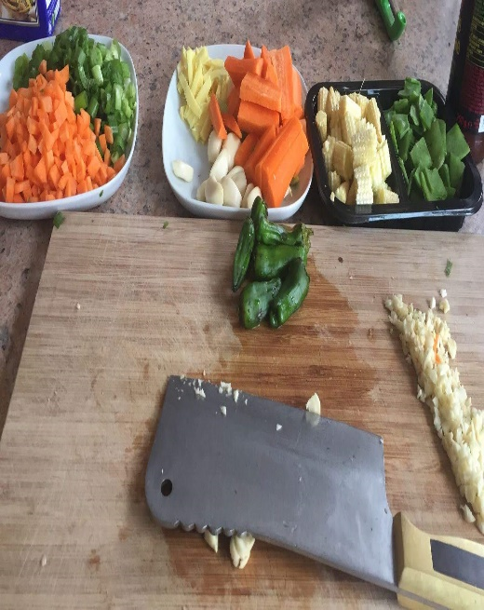 | 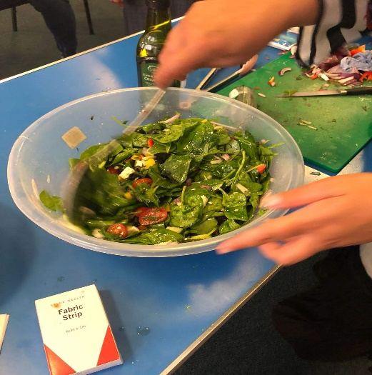  Method:  Get a large bowl add bag of baby spinach.  Dice all your ingredients apart from mint and add to the spinach.  Chop mint or coriander finely and add to the bowl then add dressing as required and mix really well.  Ready to serve.

- Recipe for HANDVO (vegetable Savoury Cake)
Handvo is a delicious savoury cake made from rice, lentils and vegetables. It is a traditional Gujrati snack enjoyed with Green Chutney or coconut chutney.
Ingredients  - ½ CUP RICE  - ½ CUP CHANA DALL (gram lentils)  - ½ URAD DALL (black lentils without skin)  - ½ cup TOOR DALL (pigeon pea lentils)  - ½ cup PLAIN YOUGURT  - ½ CUP GRATED BOTTLE GOURD OR ZUCCHINI  - ½ CUP GREEN PEAS (fresh or frozen)  - ¼ teaspoon TURMERIC POWDER  - 1 TEASPOON GRATED GINGER  - 1 TEASPOON FRESH GRATED GREEN OR RED CHILLI POWDER (To taste)  - 1 TEASPOON LEMON JUICE  - 1 TEASPOON SUGAR (optional)  - 1 teaspoon SALT or to taste  - 1 teaspoon OIL  Tarka/tempering Ingredients  - 10 - 12 CURRY LEAVES  - 2 TEASPOON MUSTARD SEEDS  - 2 TEASPOONS OF CUMIN SEEDS  - 4 TEASPOON SESAME SEEDS  - ½ TEASPOON ASAFOETIDE (hing, optional)  - 3 tablespoons good oil | 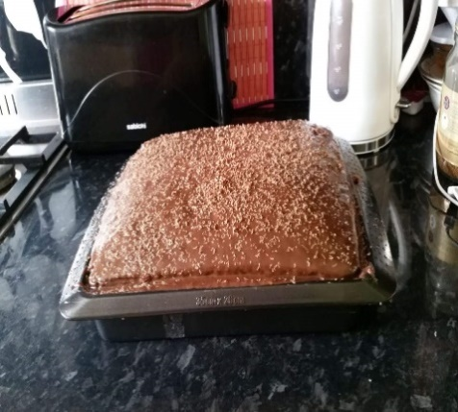  Method  Soak the rice and all the Lentils in water for about 4 hours. Rinse the rice and lentils and drain the water. Transfer them to the jar of a blender and add the plain yogurt and salt. Blend until it forms a smooth consistency. If required, add 1-2 tablespoons of water whilst grinding. NOTE (Don’t add too much water).  Transfer them to a medium size container, cover with a lid and leave it to ferment for 8-10 hrs or overnight. NOTE (This batter does not rise like the batter for idli /dosa batter)  After the fermented time check the batter and stir. You will see tiny bubbles because of the fermentation.  Add the grated vegetables, grated ginger, chillies, turmeric powder and the 1 teaspoon of oil.  Mix well and the batter should have a thick consistency (if it is watery then add 1 -2 tablespoons of sooji/semolina to make it think)  Add ½ teaspoon of baking soda and the lemon juice and sugar.  Tarka/tempering method  Heat the oil in a non-stick pan over medium heat, add the mustard seeds and when they start to crackle add the Cumin seeds, sesame seeds, asafoetida and the curry leaves.  Pour over the rice/lentil batter and pour into a greased baking tray/pan and bake in the oven on 200F for an hour.

- Recipe Cake pops/ cake balls from leftover cake
Ingredients:  - Leftover cake (Any cake like sponge / madeira / chocolate etc.)  - Nutella (You can choose an alternative like jam / fudge sauce/ cream cheese etc.)  - Lollypop sticks  - Plain chocolate (Any white / milk / black)  - Sprinkles of your choice like colourful sugar balls, chocolate rice etc.  - Styrofoam or any alternative to hold cake pops | Method:  - Crumble cake until it resembles fine crumbs.  - Add in Nutella a little bit at a time until cake is moist and look like a soft dough or can hold a ball shape. Use a spoon or your hands to incorporate the ganache into the cake crumbs.  - Gently roll the mixture into a ball and place on butter paper. Make sure there are no cracks on cake balls.  - Refrigerate for 20 to 25 minutes.  - Melt chocolate in a bowl.  - Gently roll all the balls once again and reshape them to perfect round shape.  - Dip lollypop stick in melted chocolate (about 1 centimetre) and push it into the bottom of the cake ball halfway.  - Refrigerate again for 10 minutes.  - After 10 minutes, dip cake balls carefully into the chocolate until covered.  - Let the excess chocolate drip off. Swirl and tap gently if needed.  - Add the sprinkles of your choice while the chocolate is still wet, it will harden quickly. Repeat the process with remaining cake balls.  - Lastly, Put them in refrigerator for 1 hr.

- Popular Pakistani/Indian dish Daal Chawal
Ingredients  (For Daal)  - Moong Daal 1 cup  - Masoor Daal 1 cup  - Salt 1 tsp or to taste  - Red Chilli Powder 2 tsp  - Turmeric Powder 1 tsp  - Coriander Powder 2 tsp  - Cumin Powder 1 tsp  - Garlic Paste 1 tsp  - Garam Masala Powder 1 tsp  - Tomatoes medium sized 2  - Onion 1  - Cumin Seeds 1 tsp  - Curry Leaves 8-10  - Ghee 1/2 cup  - Red Chillies whole 6  - Green Chillies 2-3  - Coriander for garnishing  (For Rice)  - Rice 2 cups  - Water 4 cups  - Salt 1 tsp  - Cumin Seeds 1 tsp  - Ghee 2-3 tsp | 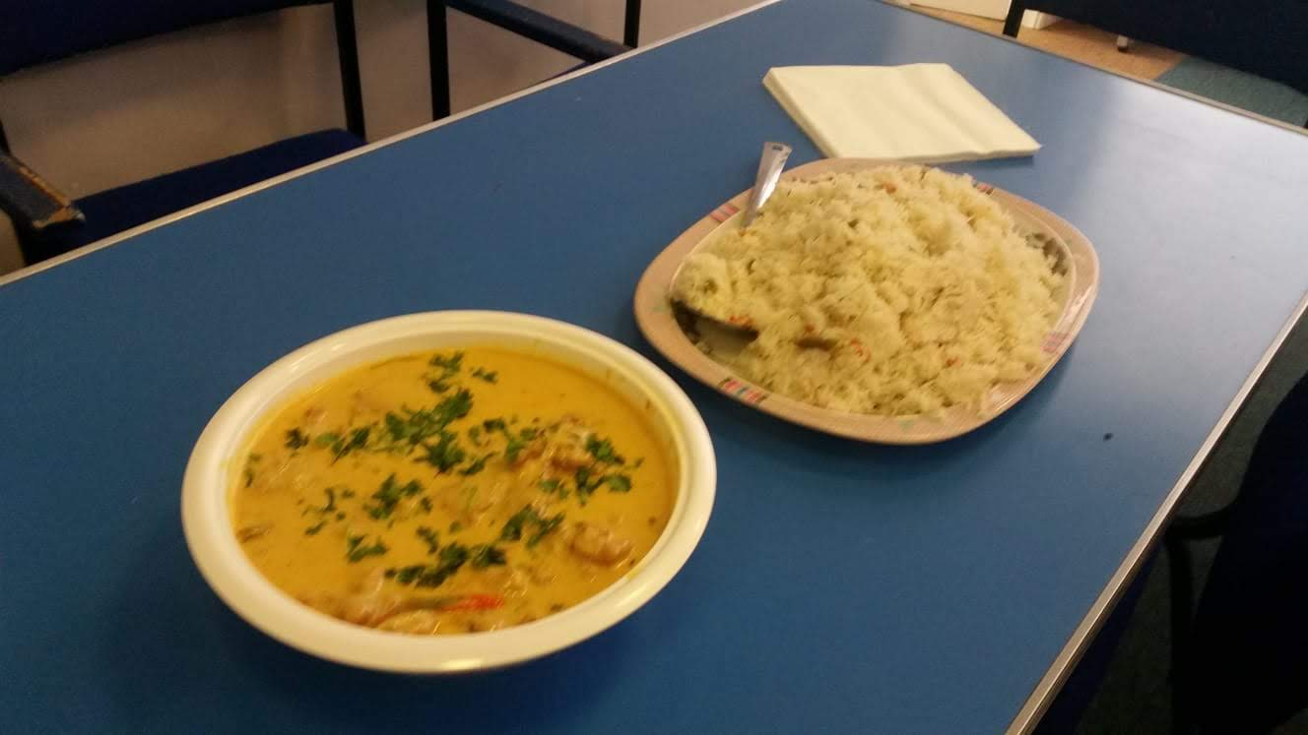  Method:  On stove when the oil get hotter add chopped onion, and when it becomes brownish add all spices salt and garlic paste and let all the ingredient to simmer and then add lentils let it cook for good half an hour when it looks like both lentils are cooked and mixed well then make tarka. Now keep the cooked lentil aside  Take 4 tsp of oil good, when it is hot, add cumin seeds and chopped garlic in it. when turn bit brown add it on top of the cooked lentil and add garnishing  Dal Is ready to serve  Rice:  Put required amount of rice and boil it till its ready desirable form, drain the extra water from rice and keep the flame to very slow after ten min you can serve it

- Besan Roti rolls
Ingredients:  - Left over chapati’s  - Besan batter  - Turmeric powder  - Chilli powder  - Salt  - Garlic -Ginger paste  For wrap stuffing, ingredients  - Green Chillies  - Fresh Coriander leaves  - Carrot 2 piece grated  - Onions chopped finely  - Tomato ketchup  - Salt  - Black pepper powder  - Chilli sauce | Procedure:  Mix all stuffing ingredient well in a bowl.  That is ready for the filling in wrap.  Just keep it aside  Mix all besan better ingredients together in a round bowl and make a thick & spicy batter.  Heat up the tava (non-stick pan)  Heat table spoon oil on the pan.  Then dip the roti in that thick batter both sides.  Shallow fry the Roti’s both sides on the pan until both side cooked by look it should be crispy and little brown.  Serve it in a plate, on top of the roti / nan  Put the ready salad mixture.  Roll it and eat it serve it.

- Rachna Daal Pakoras
Ingredients:  - Leftover daal - 1cup  - Gram flour - 1cup  - Semolina (suzi) - 1cup  - Fine chopped onions  - Crushed ginger, garlic and green chillies - 1tbspn  - Fennel seeds - 2 tsp  - Kalonji - 1tspn  - Salt to taste  - Haldi - 1/4 tsp  - Red chilli -1/2 tsp  - Coriander leaves  - Oil for deep frying | Method :  Put left over daal in bowl Add gram flour, semolina (suzi),fined chopped onion, corianders leaves, crushed ginger, garlic, green chillies, fennel seeds, kalonji, salt to taste, Haldi, Red chilli. Mix everything well. (Note Add water according to your mixture consistency if your daal is thick then add otherwise no need to add water) Heat oil in a deep pan for frying drop the pakoras one by one in hot oil fry them till golden on medium flame. Take them out and transfer to an absorbent tissue.  Pakoras are ready to be served.

- Wheat Bundiya Recipe
Ingredients  - 1/2 kg Unsalted Bundiya  - Leftover sweet syrup from Rasgulla & Gulabjamun tin  Which normally people through away  Collect it in a container and keep it in fridge for this recipe | Method:  Add bundi in a glass pot & add syrup in it then heat it up for a 5-6 min  Leave the bundiya for soaking for a little longer  Then serve it as quick new dessert

For more Asian dishes please visit
https://chetnamakan.co.uk/

