Low Carbon Communities Initiative
Networking Key Services- NKS

What to put in your recycling bins and box

Green wheelie bin: mixed recycling
- You can put these in your green wheelie bin:  - Paper and unwanted mail  - Cardboard, drinks cartons  - Clean plastic bottles, pots, tubs and trays  - Clean cans, tins, foil and empty aerosols  - Envelopes  - You can't put these in your green wheelie bin:  - Plastic bags, wrappers, crisp bags and Clingfilm  - Paper towels  - Plastic plant pots and toys  - Glass | 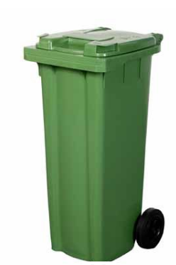

Blue box: glass and small electricals
- You can put these in your blue box:  - Glass bottles and jars  - Small electrical items placed on top or next to the box, for example hairdryers and toasters  - Household batteries placed inside a clear bag and on top of the box  - Clothing, towels, clean sheets, pairs of shoes, placed inside a plastic bag  - You can't put these in your blue box:  - Light bulbs, glass dishes, broken glass, ceramics and Pyrex  - Large electrical items, for example microwaves or larger items  - Duvets and pillows | 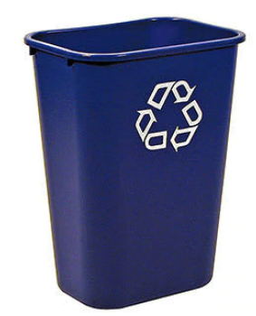

Grey food caddy: cooked and uncooked food
- Grey landfill bin
This bin is only for household waste that can't be recycled. Don't leave items or bin bags beside the bin or on the street, it's illegal.

- You can put these in your grey food caddy:  - Beans, pasta, rice and bread  - Cakes and bakery items  - Dairy items, eggs and egg shells  - Fruit and vegetables including peelings  - Meat and fish including bones  - Fast food, for example chips and pizzas  - Tea bags and coffee grounds  - You can't put these in your grey food caddy:  - Liquids including milk and cooking oil  - Food packaging | 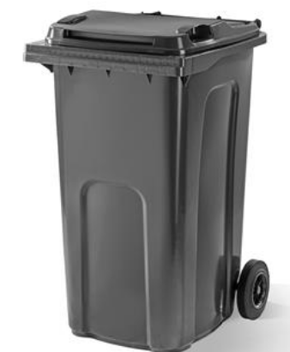

Note: Food must be bagged. You can use any small plastic bag, such as carrier bag or a bread bag, or a compostable liner. Liners are available at libraries for £1 per roll or at supermarkets. If you prefer, you can just wrap it in newspaper.

Brown wheelie bin: gardening waste
- You can put these in your brown wheelie bin:  - Flowers, plants and weeds  - Grass cuttings and leaves  - Hedge clippings, twigs and small branches  - You can't put these in your brown wheelie bin:  - Animal waste and bedding  - Plant pots  - Soil and turf | 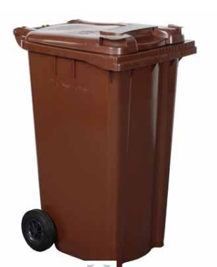

Note: Christmas trees should be cut in half and placed beside your brown garden bin in January only.

Disclaimer: As the bin colours and usage may differ in different areas, you should contact to your council if you need more information

