

**Low Carbon Communities Initiative**

**Networking Key Services- NKS**

**Energy Advice**

**Gas Central Heating System Information Sheet**

**Room Thermostat:**

Use the room thermostat to control the comfort level in your home.

Turning down the thermostat by 1 degree can cut as much as 10% from your heating bills.

The recommended settings for the room thermostat are between 18°c and 23°c.

**Boiler Thermostat:**

Typically, households set the thermostat on the boiler at around 65°c.

However, don’t be afraid to reduce the temperature to meet your needs.

The lower the thermostat is set, the less energy you are using and the more money you are saving!

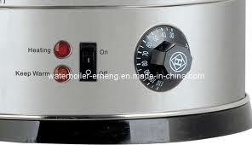

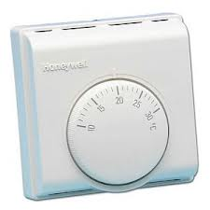

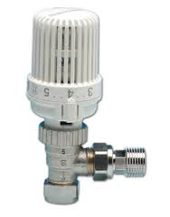

**Programmer/Timer:**

Make use of the programmer and arrange for the heating to come off and on at set times.

Your heating can be automatically switched on before you step out of bed in the morning.

Remember to take advantage of the cool-down periods.

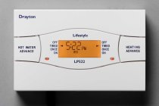

**Thermostatic Radiator Valves (TRV’s):**

TRV’s are there for you to alter the levels of heating within each radiator in each part of your home.

Don’t be afraid to use them!

There’s no point in heating rooms that are not often in use to the same level as rooms that are in use.