**Electric Storage Heaters**

**The Input Dial** (sometimes known as the Charge Control):

This control determines the amount of electricity used and therefore the amount of heat ***stored*.** What you pay is solely determined by the setting of the input control – the output control plays no part. If you set it too high for the size of room or for the time of year, you will be wasting money.

It is best to be set on a seasonal basis: medium for autumn/spring, high for winter, maximum for the very coldest weather.

If you find that you run out of heat before the end of the day, and the input is not on maximum, turn it up to store extra for the following day. When the weather gets too warm to need heating, switch your heaters off at the spur-point at the wall.

[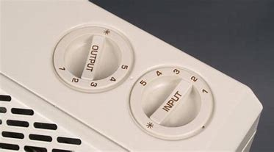](https://www.bing.com/images/search?view=detailV2&ccid=7Jiu1EK0&id=30ADBD15097F05CAF2FAA8CBF8A508BC1E1D969B&thid=OIP.7Jiu1EK0-ViIilexiHyrUAHaEG&mediaurl=https://www.cse.org.uk/img/770/770/3/downloads/image/1382116440_storage-heater-controls_cropped.jpg&exph=427&expw=770&q=Night+Storage+Heaters&simid=608038651431421248&selectedIndex=35) 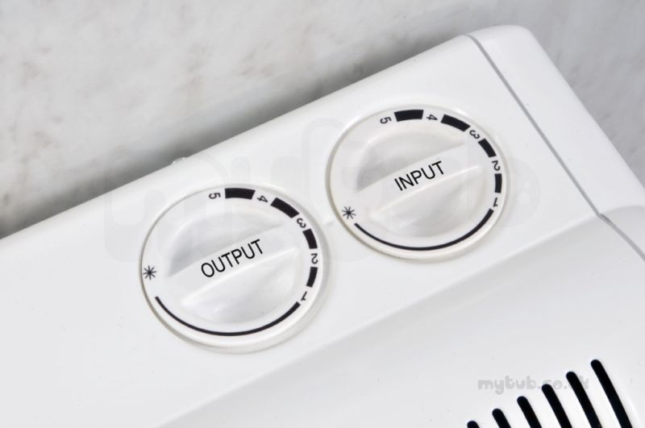

Electric storage heaters can be an efficient way to heat your home and as they run on off-peak electricity, they can be the **cheapest** electric heating if they are used correctly.

This information sheet is designed to help you get the best use from your storage heating.

**How do storage heaters work?**

Storage heaters are charged using low-cost electricity. This is then converted to heat inside a core of special firebricks. You are able to control the desired rate of heating released from the heater throughout the day.

**What heating tariffs are used for customers with storage heaters?**

Specific tariffs apply to customers with storage heating and not every supplier can support this type of heating so it is not advisable to change supplier in these circumstances. Examples of heating tariffs are Comfort plus White Meter, Comfort plus Control (Scottish Power) and Economy 7 (Scottish Gas).

**How storage heaters are controlled?**

A storage heater usually has two controls: an **input** dial and an **output** dial. Essentially, the **input** controls how much electricity the heater takes in: the higher the setting the higher the cost.

**storage heaters find themselves occasionally having to use an extra heating source, usually in the evening**. If you are too cold, remember to ensure the **output** dial is set to maximum, before deciding to switch on another source of heat. A well-controlled storage heater should give you ten or more hours of useful heat a day.

Also, make sure the **output** is set to low or minimum overnight and when you are out of the house, or you will be heating your home while you are asleep or your home is unoccupied.

**Other points:**

* Fitting shelves above your heaters is a worthwhile task as this can deflect the heat further into the room
* Please **do not** cover or dry clothes on the heater. This will prevent the heat getting out into the room and can be a fire hazard
* Please **do not** put furniture in front of your heaters. You will be spending your money heating your furniture rather than heating your home

**Hot water heating with off-peak electricity:**

If you have storage heaters, you should also be able to make use of cheaper electricity to heat your water at night. You should have a hot water timer either in your kitchen or in the cupboard near the hot water tank. The simplest of these is a Horstmann 7 quartz control.

**The Output Dial** (sometimes known as the Boost Control):

This operates a flap just inside the vent at the front of the heater to control the flow of heat released into the room. You may want to set it to low or fully closed in the morning, and turn it up as the day progresses when you need more heat.

If this is set too high from the morning, the heater will release the stored heat quicker, and there may not be enough heat to last until the evening.

**Most owners of storage heaters find themselves occasionally having to use an extra heating source, usually in the evening**.

If you are too cold, remember to ensure the **output** dial is set to maximum, before deciding to switch on another source of heat. A well-controlled storage heater should give you ten or more hours of useful heat a day.

Also, make sure the **output** is set to low or minimum overnight and when you are out of the house, or you will be heating your home while you are asleep or your home is unoccupied.

**Other points:**

* Fitting shelves above your heaters is a worthwhile task as this can deflect the heat further into the room
* Please **do not** cover or dry clothes on the heater. This will prevent the heat getting out into the room and can be a fire hazard
* Please **do not** put furniture in front of your heaters. You will be spending your money heating your furniture rather than heating your home

**Hot water heating with off-peak electricity:**

If you have storage heaters, you should also be able to make use of cheaper electricity to heat your water at night. You should have a hot water timer either in your kitchen or in the cupboard near the hot water tank. The simplest of these is a Horstmann 7 quartz control.

Information Technology Solutions

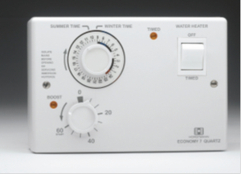

This will automatically switch on your immersion for about five hours a night when the cheap electricity is available and allow you to heat extra water during the day using a boost control. It is much more expensive to heat water up during the daytime so check your timer is set up correctly as follows:

Check the clock on the timer shows the correct time

Check the timer is set so the water is heated during the off peak period, usually 11:30pm to 7:30am