Low Carbon Communities Initiative
Networking Key Services- NKS

Guide to Successful Container Gardening…..

The idea of growing our own vegetables and herbs is gaining popularity in the UK (possibly thanks to Felicity Kendal and ‘The Good Life’ circa 1975). However, not all of us have access to a garden, especially in large cities. So, what can you do if you would like to grow some veggies at home, but don’t have a garden or much space to work with? Don’t worry, you can still put those green fingers to good use!
For many people in British cities, container gardening is the answer to this dilemma due to its simplicity and convenience. You can grow your favourite herbs and vegetables in small gardens, balconies, window sills, and even in an apartment. All you need is a sunny spot and this guide to get started.
Content of read:
- What is a container garden and what are the benefits of having one?
- When to plant in containers
- Need a Gardener?
- January/February
- March/April/May
- Choosing the right container
- Maintaining your garden
- Companion potting

What is a container garden and what are the benefits of having one?

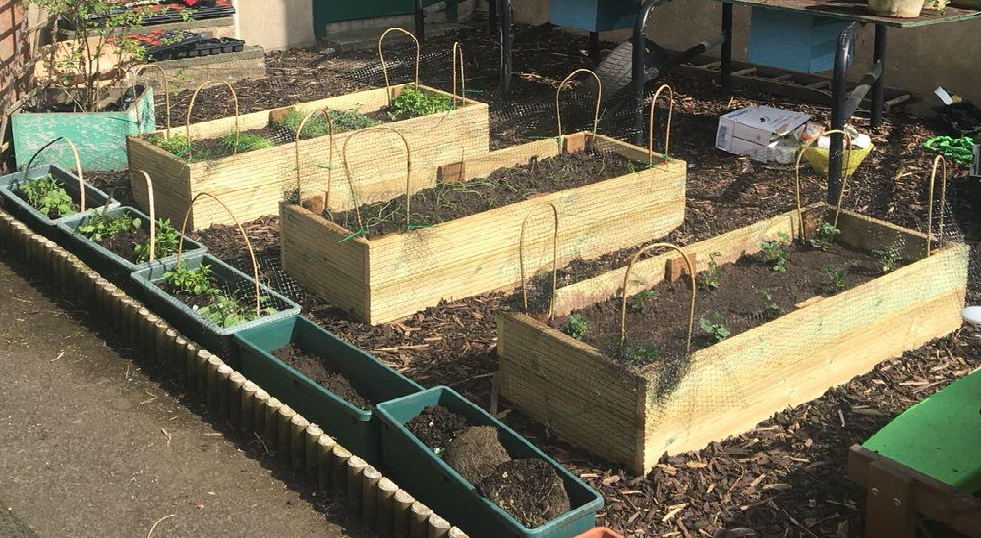
To put it simply, container gardening is the growing of plants in garden pots of various shapes and sizes. This method of gardening is exceedingly convenient as there is no need to dig and prepare a plot, no tedious weeding, it doesn’t require a lot of space, and you can easily protect your plants from frost by bringing them inside if there is a particularly nasty cold snap.
Another benefit is that you don’t need to have much experience. Ensuring that the soil in your garden is suitable for growing vegetables and herbs can be a daunting task for beginner gardeners. With container gardens, on the other hand, you don’t need to worry about this as you control the type and quality of soil that’s being used.
Also, if you have children, growing plants in pots is a great way to introduce them to growing their own food and understanding where food comes from. It can also be used as a good exercise in responsibility if you give them a plant to look after.

When to plant in containers

It is well known that plants grow and flourish at different times of the year. This is especially true in regards to vegetables and, if you are new to gardening, it can be difficult knowing when to plant. Some plants, such as tomatoes and onions, should not be planted in containers directly as the seeds are at risk of rotting before being given the chance to sprout. Plants with this requirement should be planted indoors and allowed to grow for up to 2 months before being transplanted to larger containers.
In order to cultivate a successful container garden and receive a bountiful harvest, follow our planting guide below.

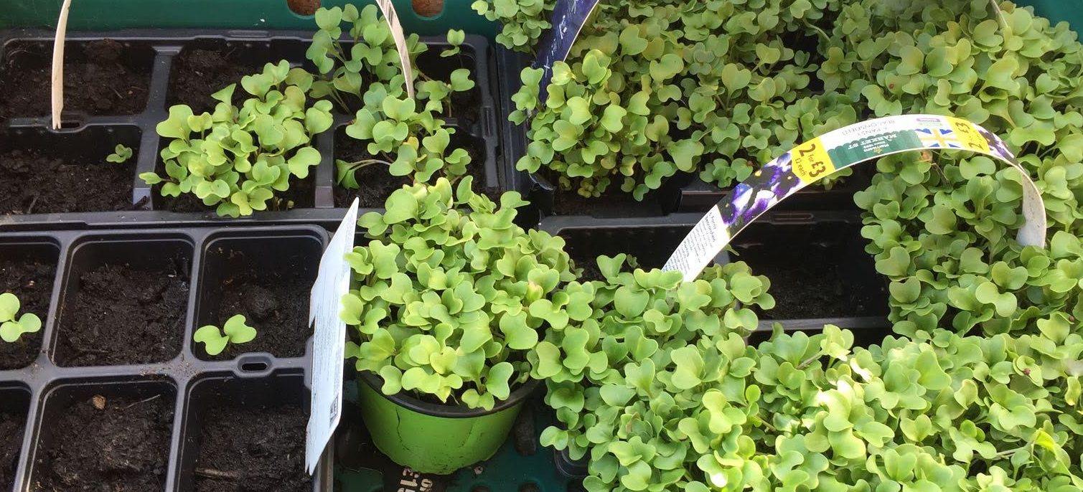

January/February | March/April/May
This is the perfect time to get tomatoes, peppers, garlic, and onions started. Plant these in seed trays indoors and allow them to grow for 6-8 weeks before transplanting to larger containers. If you would like to grow herbs, basil, chives, dill, oregano, parsley, and thyme, plant them in late January – early February as this is when you’ll get the optimal results. | The warmer months of spring are the best time to plant the bulk of your vegetables and herbs to enjoy a late summer harvest.  - Beans;  - Broccoli;  - Cabbage;  - Carrots;  - Herbs – any other herbs you would like that weren’t planted previously;  - Lettuce;  - Garlic, tomatoes, peppers, and onions – now that they have sprouted, transplant the plants to larger containers;  - Potatoes;  - Spinach.

Choosing the right container
Now that you know what to plant and when it is time to discuss containers and learn how to choose the correct type. You would be forgiven for thinking that any old plant pot will do, but the wrong container can mean the difference between a meagre and a bountiful harvest.
The first thing to consider when choosing your plant pots is the size of the containers. If they are too small, the plant’s growth (and eventual harvest) will be negatively impacted as the roots will not have sufficient space. If the container is too large the soil can become waterlogged, which can lead to root rot and your plants dying. The staff at your local garden centre can help you choose the right container size for the plants you will grow.
Once you know which size of plant pot you have to buy, the next aspect to consider is the material of which the containers are made from. Your choice of material depends on where you want to grow your produce and if you intend on bringing your plants inside during the winter months.
- Terracotta – These heavy plant pots are great if you plan on leaving them outdoors during the colder months. The thickness of the material keeps the contents well insulated, protecting the roots from most of the negative effects of frost.
- Glazed ceramic – These durable containers are one of the best choices for adding a bit of flair, colour, and style to your containers garden and have insulating properties similar to terracotta pots. However, they can be quite expensive and difficult to move due to their considerable weight.
- Plastic – The most affordable option available, plastic plant pots come in a variety of shapes, sizes, and colours to suit all tastes. Lightweight containers, such as these, are easy to move and some are frost-resistant, meaning that they can be left outdoors during the winter. Just keep in mind that, even though they are frost-resistant, they can still crack if they face a particularly cold winter.
- Wooden containers – Usually made from a cut-in-half barrel, these are arguably the best looking containers around. The downside is that the difficulty of moving them around increases as they age.
- Concrete – The heaviest and most durable type of containers, these are only suitable if they are kept in the same place all year round.
Lastly, the shape of the container is also important. Some containers are prone to tipping over as plants grow and become top-heavy, especially in windy areas (think balconies and roof gardens). Generally, the wider the base, the more stable a container will be. Square, rectangular, and cylindrical containers are the most stable options, while the traditional inverted cone-shaped containers are the least stable.

Maintaining your garden
You are well on your way to cultivating a healthy, flourishing container garden. You know what you would like to grow and have purchased the ideal containers. All that’s left is to take proper care for your plants so that your efforts aren’t wasted. Don’t worry, for we’ve got you covered here as well.
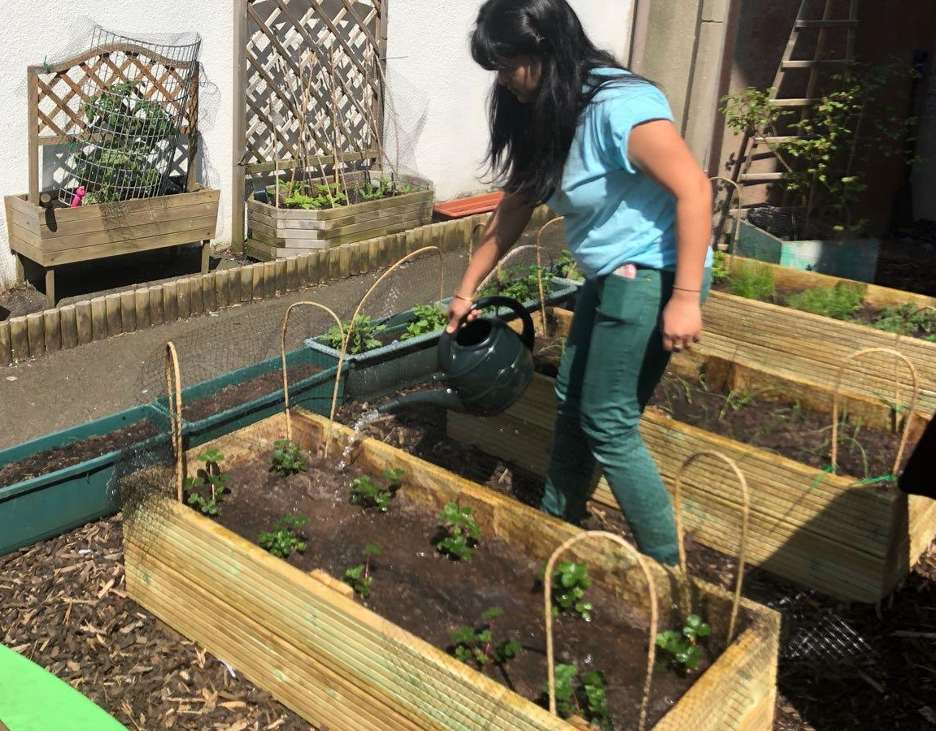
- Throughout April-September, check the moisture levels of the soil in each container daily and water, if it has dried out. A general rule of thumb is to water your plants twice a day during the warmer months.
- Reduce the watering schedule during winter as your plants won’t be expending as much energy for their growth.
- In very wet or cold conditions, either cover your plants or move them indoors or to another covered area to prevent the soil from becoming waterlogged or frozen.
- Remove dead leaves and flower heads regularly to encourage growth.
- If you are going to use liquid plant food, start feeding your plants once they have grown for at least 6 weeks. Feeding should take place from April-September and you should only use plant food if the compost that you use does NOT contain a slow-releasing fertiliser.
- To keep plants healthy, you should aim to repot them in early spring each year. This keeps the compost fresh and prevents roots from drying out.

Companion potting

If you would like to take your container garden to the next level, you may want to consider companion planting. This involves placing plants, which are beneficial to each other, in the same container. The benefits include better protection against pesky insects, aided growth, and your plants generally looking fantastic.
While a lot of herbs can be grown together, some prefer different conditions in order to flourish and some need to be planted on their own as they don’t play well with others.
- Drier soil and plenty of sun – sage, thyme, rosemary, marjoram, oregano, dill;
- Soil with more water – basil and parsley;
- Mint should always be planted on its own as it spreads quickly and overruns nearby plants.
As mentioned previously, some pairings are beneficial as they keep insects away or attract predatory insects to eat the ones that want nothing more than to nibble on your plants. Some examples of beneficial pairings are:
- Tomatoes and basil – not only will this combination keep flies at bay, but it can also enhance the flavour of your tomatoes;
- Cucumbers and dill – this combination will attract predatory insects, such as wasps, to eat the aphids that want to snack on your plants;
- Beans and marigolds – keeps aphids and beetles at bay.
You can also create herb container combinations for specific foods and meals. This will not only impress your friends and family, but also add more convenience when you are preparing a meal. To help, we have put together a selection of herb combinations you can grow for specific foods.
- Chicken dishes – thyme, rosemary, coriander, marjoram, and sage.
- Fish dishes – chives, dill, and marjoram.
- Pork dishes – sage, rosemary, and thyme.
- Beef dishes – rosemary, thyme, and basil.
- Lamb dishes -rosemary, thyme, parsley, mint (remember to grow mint in its own container).
- For roasted or steamed vegetables – thyme, rosemary, oregano, marjoram, and dill.
- For roasted or steamed potatoes – rosemary, thyme, and parsley.

