Low Carbon Communities Initiative
Networking Key Services- NKS

What to put in your recycling bins and box

Green wheelie bin: mixed recycling
- You can put these in your green wheelie bin:  - Paper and unwanted mail  - Cardboard, drinks cartons  - Clean plastic bottles, pots, tubs and trays  - Clean cans, tins, foil and empty aerosols  - Envelopes  - You can't put these in your green wheelie bin:  - Plastic bags, wrappers, crisp bags and Clingfilm  - Paper towels  - Plastic plant pots and toys  - Glass | 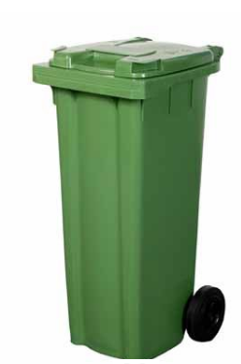

Blue box: glass and small electricals
- You can put these in your blue box:  - Glass bottles and jars  - Small electrical items placed on top or next to the box, for example hairdryers and toasters  - Household batteries placed inside a clear bag and on top of the box  - Clothing, towels, clean sheets, pairs of shoes, placed inside a plastic bag  - You can't put these in your blue box:  - Light bulbs, glass dishes, broken glass, ceramics and Pyrex  - Large electrical items, for example microwaves or larger items  - Duvets and pillows | 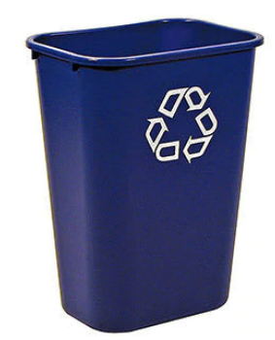

Grey food caddy: cooked and uncooked food
- You can put these in your grey food caddy:  - Beans, pasta, rice and bread  - Cakes and bakery items  - Dairy items, eggs and egg shells  - Fruit and vegetables including peelings  - Meat and fish including bones  - Fast food, for example chips and pizzas  - Tea bags and coffee grounds  - You can't put these in your grey food caddy:  - Liquids including milk and cooking oil  - Food packaging | 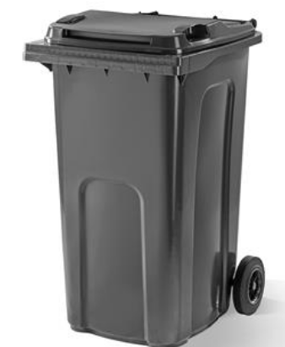

Note: Food must be bagged. You can use any small plastic bag, such as carrier bag or a bread bag, or a compostable liner. Liners are available at libraries for £1 per roll or at supermarkets. If you prefer, you can just wrap it in newspaper.

- Grey landfill bin
This bin is only for household waste that can't be recycled. Don't leave items or bin bags beside the bin or on the street, it's illegal.

Brown wheelie bin: gardening waste
- You can put these in your brown wheelie bin:  - Flowers, plants and weeds  - Grass cuttings and leaves  - Hedge clippings, twigs and small branches  - You can't put these in your brown wheelie bin:  - Animal waste and bedding  - Plant pots  - Soil and turf | 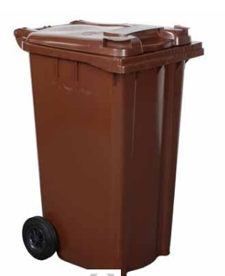

Note: Christmas trees should be cut in half and placed beside your brown garden bin in January only.

